Cancel Order as Student

Document Information

|  |  |
| --- | --- |
| **Document Title** | Title of use case – Verb Noun phrasing is almost always the most appropriate! |
| **Document Owner** |  |
| **Version** |  |
| **Status** |  |
| **Date** |  |

1. Brief Description

This use case allows parent to cancel an order of a student whose accounts were linked to each other before a specified time and have the canceled amount added back to the student’s account.

1. Actors

* Parent

1. Trigger

The parent decides to cancel an order of a student whose accounts were linked to each other.

1. Pre-Conditions

* The parent must be logged into the system.
* The student must have an existing order.
* The cancellation request must be made before the specified time.
* The parent and student’s accounts must be linked to each other.

1. Post-Conditions

* The order status is updated from “confirmed” to "canceled".
* The canceled amount is added back to the student's account balance.

1. Basic Flow
2. The parent logs in to the system.
3. The student navigates to “My Order” section.
4. The system displays a list of orders made by the student whose account was linked to the parent account.
5. The parent selects the order which is available to be cancelled.
6. The parent selects the "Delete" option.
7. The system prompts a message to confirm with the parent that they want to cancel the order.
8. The parent selects “Agree” button to confirm cancelling the order.
9. The system updates the order status from “confirmed” to “cancelled”.
10. The system adds the canceled amount back to the student's account balance.
11. The system returns the student to “My Order” page.
12. Alternate Flows
13. Exception Flows

* 4a. If the parent selects the order after the specified time for canceling orders, the system displays a message informing the parent that it is too late to cancel the order. Return to step 3.
* 7a. If the parent selects “Agree” button after the specified time for canceling orders, the system displays a message informing the parent that it is too late to cancel the order. Return to step 3.
* 7b. If the parent wants to cancel the order cancellation, select “Cancel” button.

1. Business Rules

* The parent can only cancel the order for the student’s account which was linked to their account.
* The specified time for canceling orders should be 1 day before the ordered day.
* The amount refunded for a canceled order should be equal the order amount.

1. Non-Functional Requirements

* The system should process the cancellation and refund quickly to prevent delays for other users (1s).
* The system should provide clear and concise messaging to the parent throughout the cancellation process.

1. Supplemental Requirements
2. Visual Model

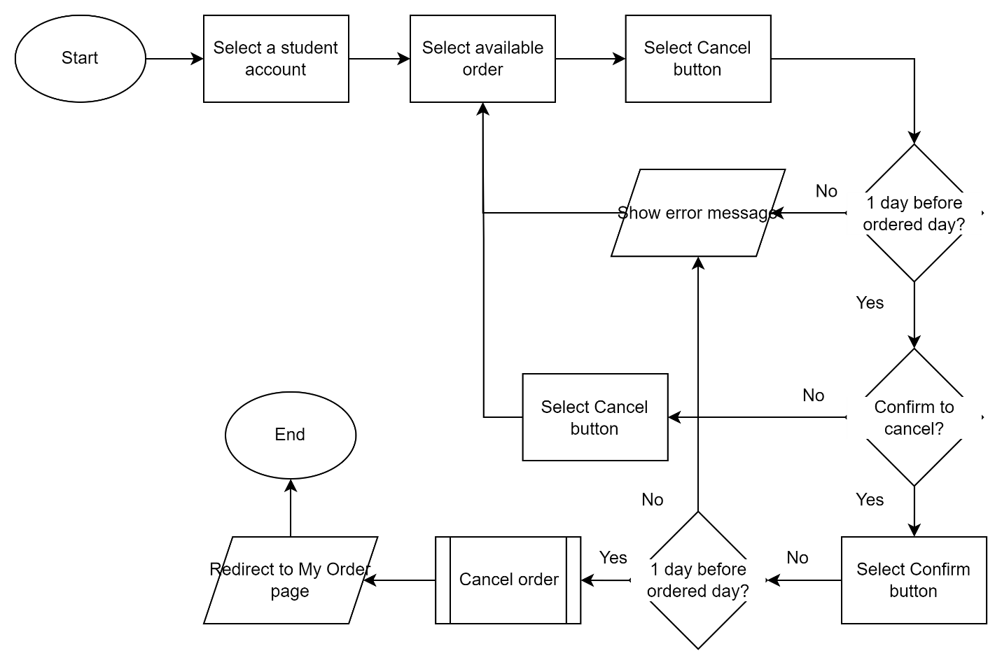

Revision History

|  |  |  |  |  |
| --- | --- | --- | --- | --- |
| V. | Date | Author | Description | Status |
|  |  |  |  |  |
|  |  |  |  |  |